**DAILY ONLINE ACTIVITIES SUMMARY**

|  |  |  |  |  |  |  |
| --- | --- | --- | --- | --- | --- | --- |
| **Date:** | | **3 JULY 2020** | **Name:** | | **KHATHEEJA SAFREENA.** | |
| **Sem & Sec** | | **4th SEM 'A' Section** | **USN:** | | **4AL18CS037.** | |
| **Online Test Summary** | | | | | | |
| **Subject** | N/A | | | | | |
| **Max. Marks** | N/A | | | **Score** | N/A | |
| **Certification Course Summary** | | | | | | |
| **Course** | | **FUNDAMENTALS OF DIGITAL MARKETING.** | | | | |
| **Certificate Provider** | | **Google digital garage.** | | **Duration** | | **40 hour** |
| **Coding Challenges** | | | | | | |
| **Problem Statement: 2 problems uploaded.**  .  For example | | | | | | |
| **Status: completed** | | | | | | |
| **Uploaded the report in Github** | | | | **Yes** | | |
| **If yes Repository name** | | | | **[http://shafreenasharief / lockdown-coding](http://shafreenasharief / lockdown-coding" \o "http://shafreenasharief / lockdown-coding)** | | |
| **Uploaded the report in slack** | | | | **Yes** | | |

Certification Course Details: (Attach the snapshot and briefly write the report for the same)

Coding Challenges Details: (Attach the snapshot and briefly write the report for the same)

**CERTIFICATION COURSE SUMMARY:**

Today I started new course **FUNDAMENTALS DIGITAL MARKETING** through **GOOGLE** **DIGITAL GARAGE** the course is secluded for 6hrs. After the completion of course, certificate will be provided. I completed all the module .I attempted quiz ,which gave me a clear veiw about the topics that were thought and discussed.It consists of 7 modules which also include assessments.



**CODING CHALLENGES DETAILS:**

Today I solved 2 coding challenge,

**1.You are given a string and your task is to swap cases. In other words, convert all lowercase letters to uppercase letters and vice versa.**

For Example:

Www.HackerRank.com → wWW.hACKERrANK.COM

Pythonist 2 → pYTHONIST 2

Input Format

A single line containing a string S.

Output Format:

Print the modified string S.

Sample Input:

HackerRank.com presents "Pythonist 2".

Sample Output:

hACKERrANK.COM PRESENTS "pYTHONIST 2".

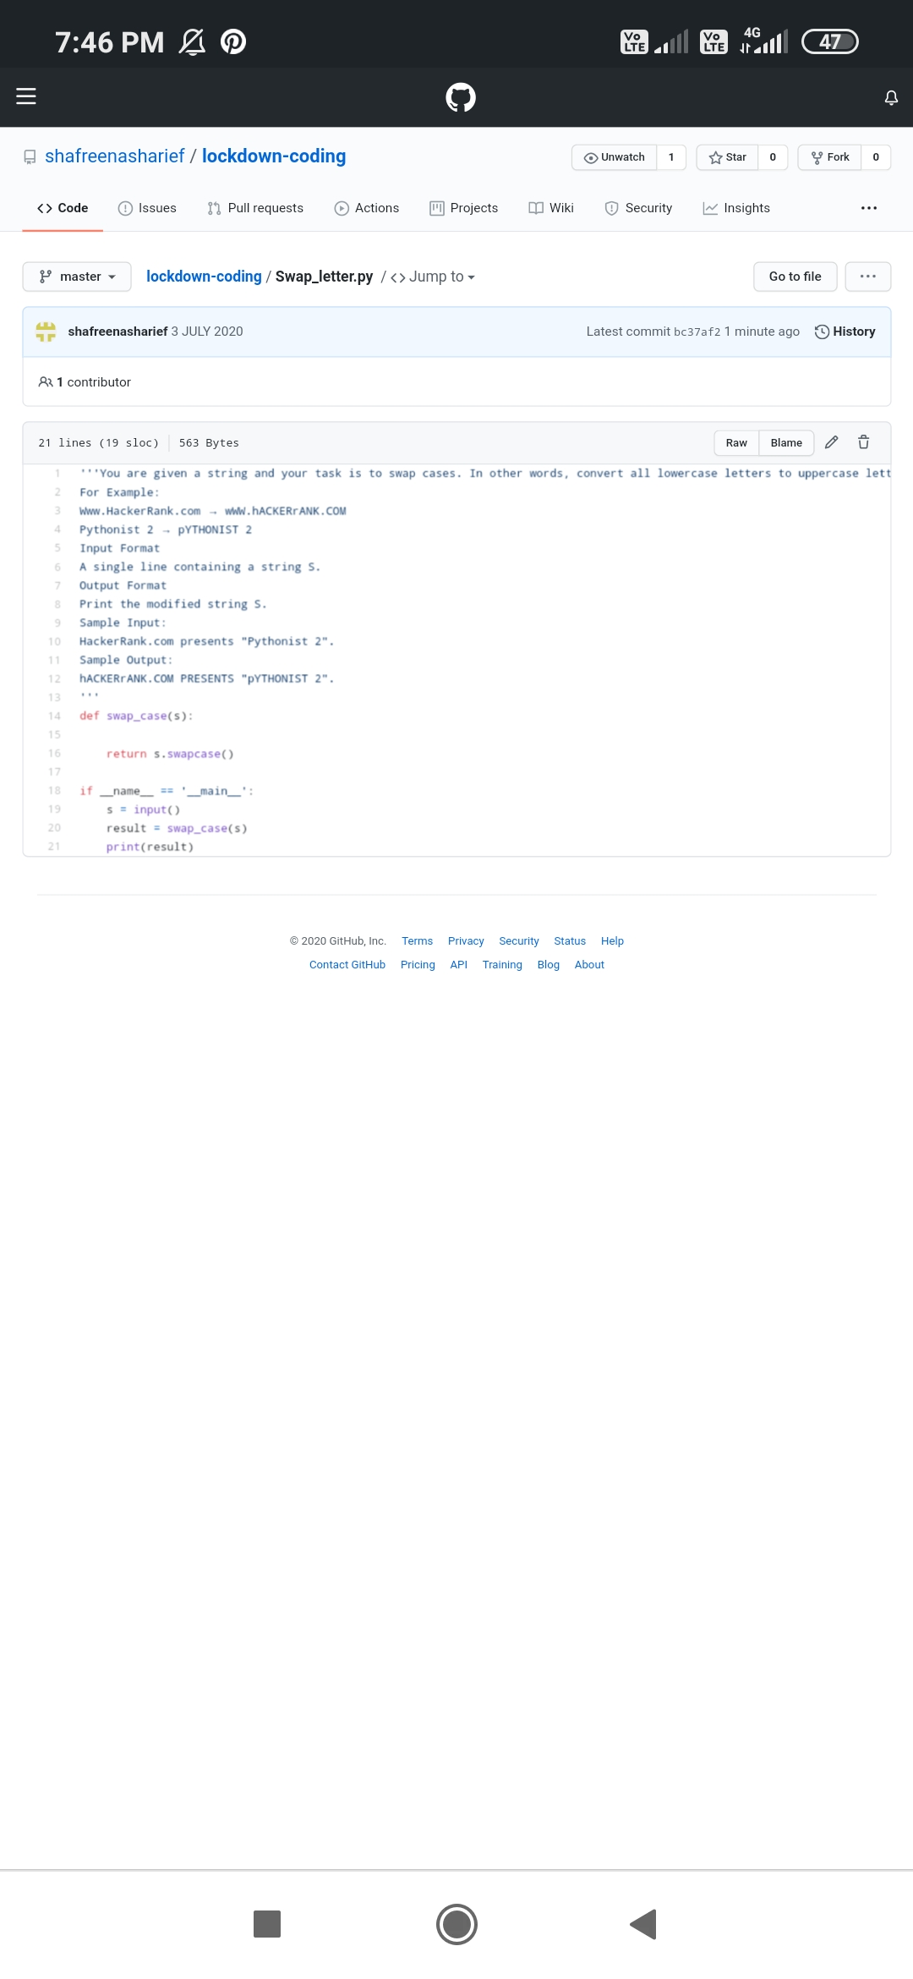

**2. You have a record of N students. Each record contains the student's name, and their percent marks in Maths, Physics and Chemistry. The marks can be floating values. The user enters some integer N followed by the names and marks for N students. You are required to save the record in a dictionary data type. The user then enters a student's name. Output the average percentage marks obtained by that student, correct to two decimal places.**

Input Format:

The first line contains the integer N, the number of students. The next N lines contains the name and marks obtained by that student separated by a space. The final line contains the name of a particular student previously listed.

Output Format:

Print one line: The average of the marks obtained by the particular student correct to 2 decimal places.

Sample Input: 3

Krishna 67 68 69

Arjun 70 98 63

Malika 52 56 60

Malika

Sample Output: 56

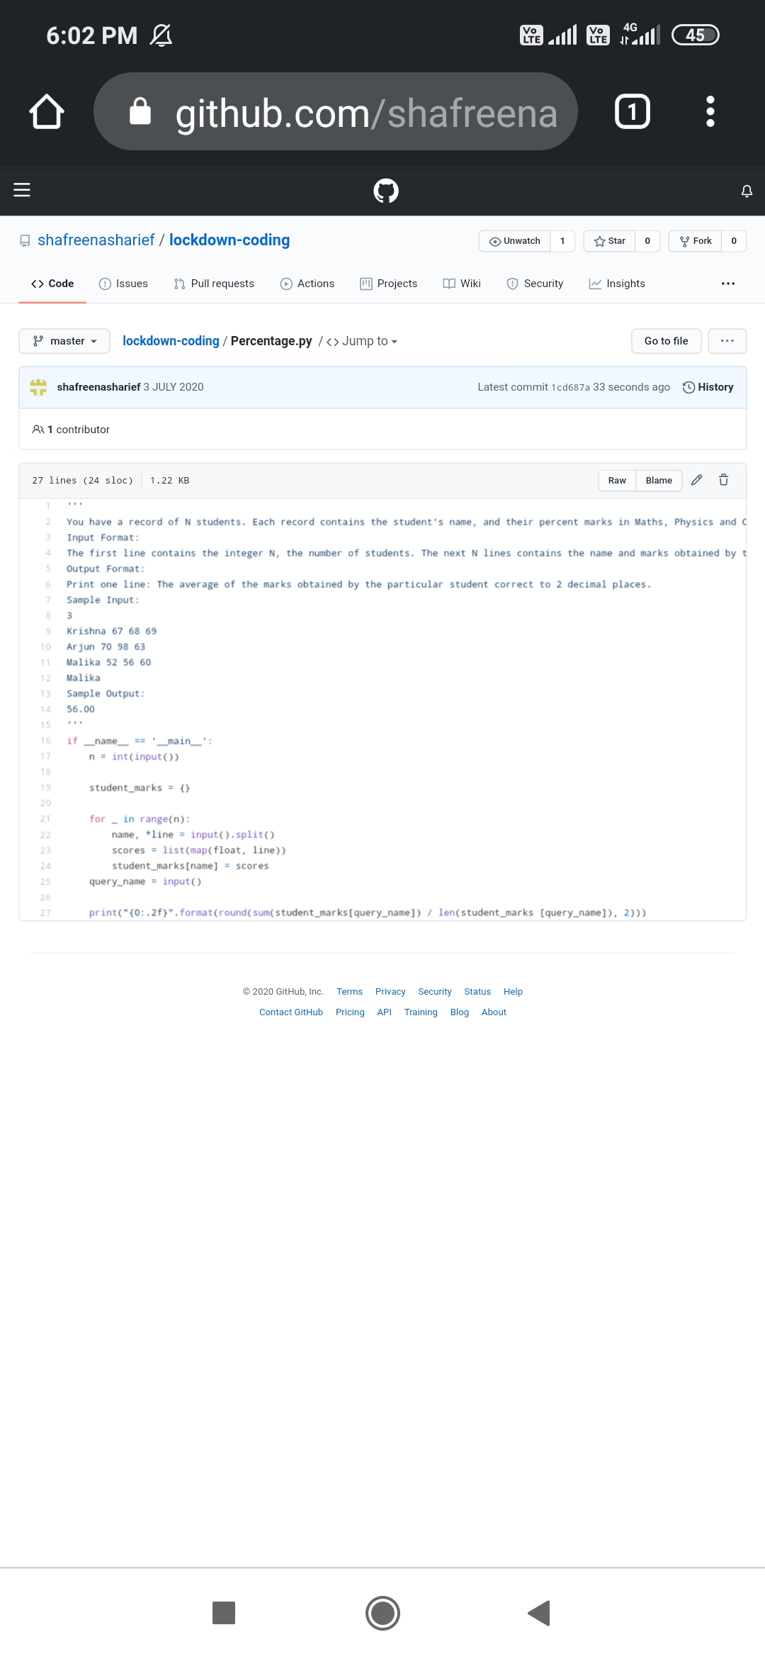

**EXTRA ACTIVITIES**:

Today I have attended the webinar on "**C**” by Ms. Megha Hedge CSE department, AIET. The session was very interesting. There was assessment conducted based on the webinar.

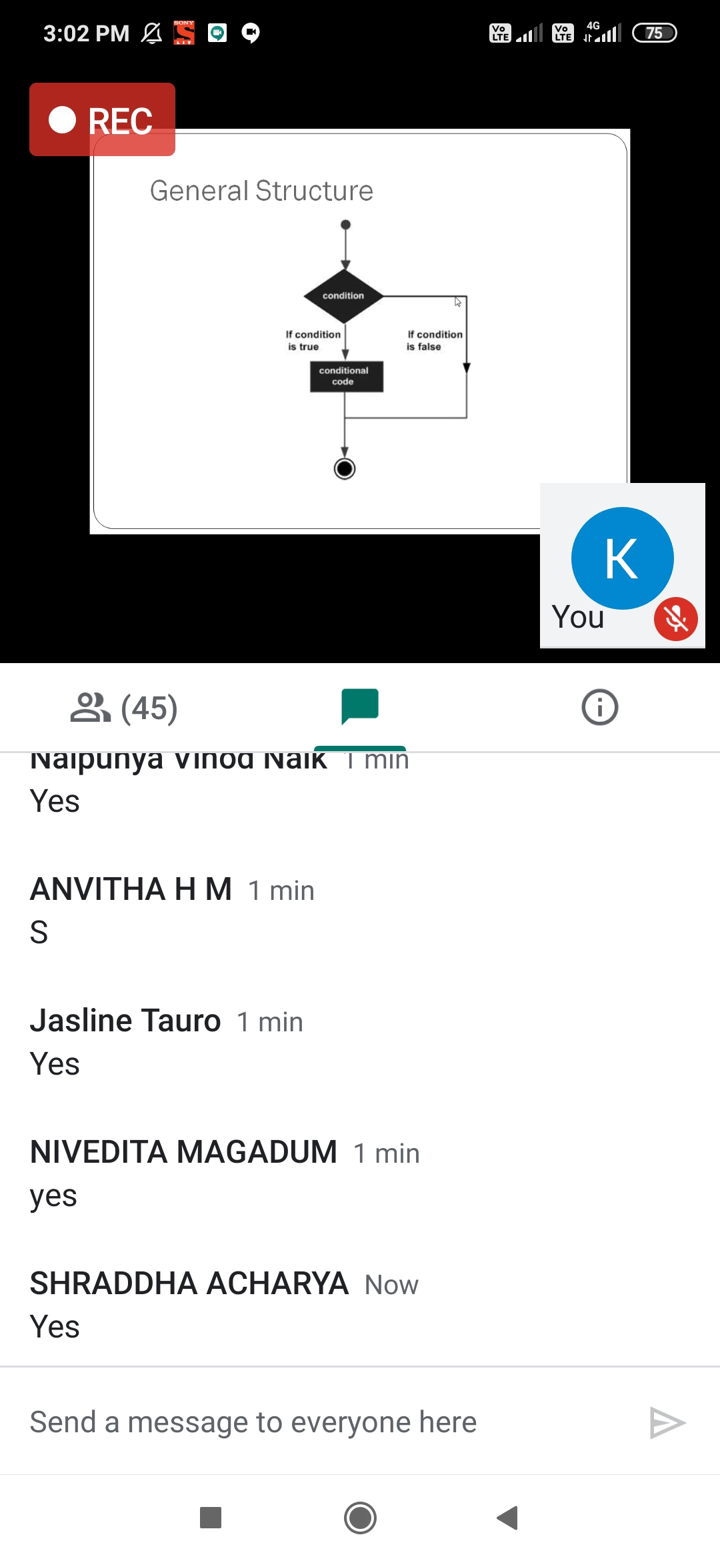

**SOLUTION** : I have uploaded the solution of the above 1 coding problems in my GitHub repository.

http://shafreenasharief / lockdown-coding

[http://shafreenasharief / locked-down--certification-course](http://shafreenasharief / locked-down--certification-course" \o "http://shafreenasharief / locked-down--certification-course)

[http://shafreenasharief / Daily\_Report](http://shafreenasharief / Daily_Report" \o "http://shafreenasharief / Daily_Report)